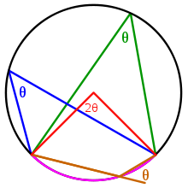COMM 301

Proposal and Research Plan

Please discuss the angles you intend to explore for our Yes/No/Maybe So project and consider the research involved.

Our organizing question is: Should KU abolish the capstone thesis project?

Yes…

No…

Maybe So….

**Angle 1:** YES. KU should abolish the thesis project. What aspect of this question would you like to focus on? Discuss it here briefly.

**Angle 2:** NO. KU should keep the thesis project as it is today. What aspect of this question would you like to focus on? Discuss it here briefly.

**Angle 3:** MAYBE SO. KU should modify or change the current thesis project. Describe your vision for change here. Include at least two reasons this change would help (choose any of these) students, faculty, coops, and/or KU.

**Primary research:** Interviews, surveys, testing, observation, etc. For each angle, brainstorm how you could do some quick primary research for this project?

**Secondary research:** History, background, reports, discussions of other programs, other internships, thesis materials, websites, articles, stats, figures, etc. For each angle, what would kind of information would be helpful? Where might you find it?

Please write a paragraph for each bolded heading above. The more detail you work out here on paper here, the easier it is to write the final draft.

A successful proposal has a professional style, shows an understanding of angles, includes valuable research, and demonstrates depth of thought.

Upload to Assignment Submission on Blackboard.